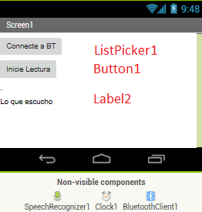

Connect to Bluetooth

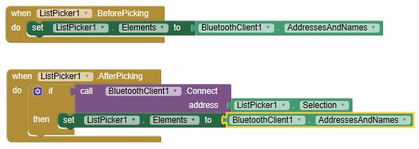

Timer interval a 1,000

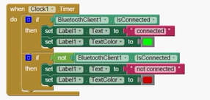

O mas sencillo

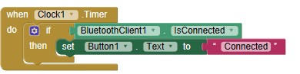

Presiona boton para grabar

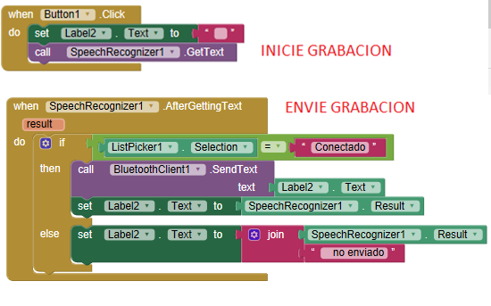

**Arduino Program.**

#include

SoftwareSerial BT(10, 11); //TX, RX respetively

String device = “”;

void setup() {

BT.begin(9600);

Serial.begin(9600);

pinMode(3, OUTPUT);

}

//-----------------------------------------------------------------------//

void loop() {

while (BT.available())

{

//Check if there is an available byte to read

delay(10); //Delay added to make thing stable

char c = BT.read(); //Conduct a serial read

device += c; //build the string.

}

if (device.length() > 0) {

Serial.println(device);

if(device.toLowerCase() == "light on") { digitalWrite(3, HIGH); device = “” };

if(device.toLowerCase() == "light off") { digitalWrite(3, LOW) device = “” };

}

}